Project Design Phase-II

Data Flow Diagram & User Stories

|  |  |
| --- | --- |
| Date | 10 October 2022 |
| Team ID | **PNT2022TMID27475** |
| Project Name | Retail Store Stock Inventory Analytics |
| Maximum Marks | 4 Marks |

# Data Flow Diagram:

A Data Flow Diagram (DFD) is a traditional visual representation of the information flows within a system. A neat and clear DFD can depict the right amount of the system requirement graphically. It shows how data enters and leaves the system, what changes the information, and where data is stored.

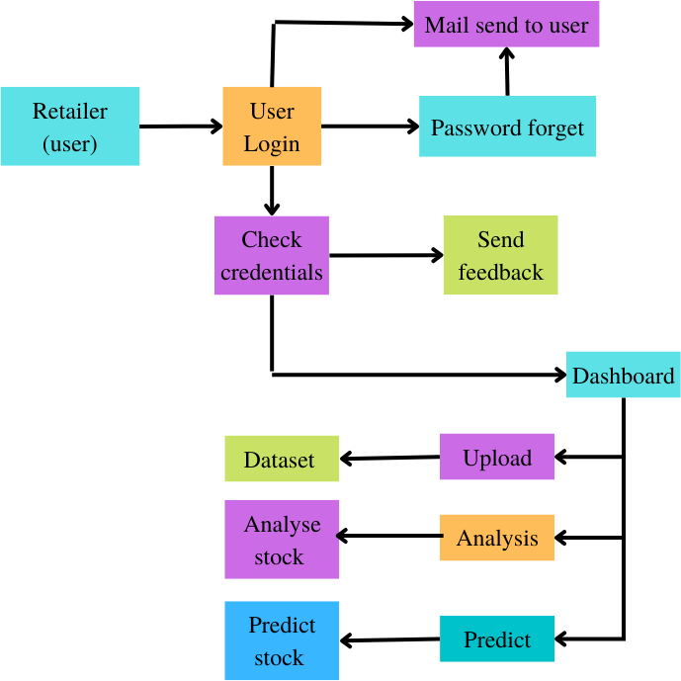

# Product Backlog, Sprint Schedule, and Estimation (4 Marks)

Use the below template to create product backlog and sprint schedule

|  |  |  |  |  |  |  |
| --- | --- | --- | --- | --- | --- | --- |
| **Sprint** | **Functional Requirement (Epic)** | **User Story Number** | **User Story / Task** | **Story Points** | **Priority** | **Team Members** |
| Sprint-1 | Registration | USN-1 | As a user, I can register for the application by entering my email, password, and confirming  my password. | 10 | High | Joel,Logesh |
| Sprint-1 | Confirmation | USN-1 | As a user, I will receive confirmation email once I have registered for the application | 10 | Medium | Joel,Logesh |
| Sprint-2 | Front end | USN-2 | As a user, to access the homepage as well as dashboard and to use the prediction algorithm of the product. | 20 | High | Paul Sujan,Mandi Mohammed  Zayaan |
| Sprint-3 | Building prediction algorithm | USN-3 | As a user, I can access the prediction algorithm and get valid and legit predictions. | 20 | High | Paul Sujan,Mandi Mohammed  Zayaan |
| Sprint-4 | View and search of products | USN-4 | As a user, I can view and search the services available in the product. | 10 | Medium | Paul Sujan,Joel |
| Sprint-4 | Reports and Invoice generation | USN-5 | As a user, I can view the reports and invoice for the services used. | 10 | Medium | Logesh,Man di Mohammed  Zayaan |

# Project Tracker, Velocity & Burndown Chart: (4 Marks)

|  |  |  |  |  |  |  |
| --- | --- | --- | --- | --- | --- | --- |
| **Sprint** | **Total Story Point**  **s** | **Duration** | **Sprint Start Date** | **Sprint End Date (Planned)** | **Story Points Completed (as on Planned End Date)** | **Sprint Release Date (Actual)** |
| Sprint-1 | 20 | 6 Days | 24 Oct  2022 | 29 Oct 2022 | 20 | 29 Oct 2022 |
| Sprint-2 | 20 | 6 Days | 31 Oct  2022 | 05 Nov 2022 | 20 | 05 Nov 2022 |
| Sprint-3 | 20 | 6 Days | 07 Nov  2022 | 12 Nov 2022 | 20 | 12 Nov 2022 |
| Sprint-4 | 20 | 6 Days | 14 Nov  2022 | 19 Nov 2022 | 20 | 19 Nov 2022 |

**Velocity:**

Imagine we have a 10-day sprint duration, and the velocity of the team is 20 (points per sprint). Let’s calculate the team’s average velocity (AV) per iteration unit (story points per day)

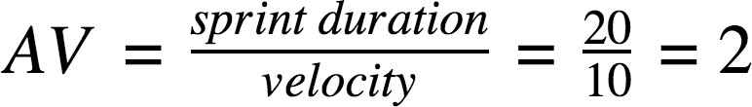

# Burndown Chart:

A burn down chart is a graphical representation of work left to do versus time. It is often used in agile [software development](https://www.visual-paradigm.com/scrum/what-is-agile-software-development/) methodologies such as [Scrum](https://www.visual-paradigm.com/scrum/scrum-in-3-minutes/). However, burn down charts can be applied to any project containing measurable progress over time.

